**EFFICIENT MARKET HYPOTHESIS REPORT**

**Table of Contents**

Introduction 3

Illustrate the efficiency or lack of efficiency in the capital markets 3

Total shareholder return 4

Conclusion 6

Reference list 8

Appendix 9

# Introduction

Capital market operating through investors and retailers’ participation, where buying and selling of stock would decide the stock price of a company. Determining potential ATI of capital market investors identifies previous returns of specific companies to gain knowledge about father investment. In this report Tesco PLC and Mark and Spencer PLC would be considered as potential investment companies for investors by analysing the return and dividend of those organisations. Additionally, organisations return calculation regarding dividend policies effective to understanding actual potentiality of the capital market. Efficiency and lack of efficiency in the capital market would be analysed by return generation in the last 5 years.

# Illustrate the efficiency or lack of efficiency in the capital markets

Illustration of efficiency of the capital market considered actual gold percent Charity in future based on previous growth. Capital market growth is dependent on performance of individual sectors or industries represented as accumulator economic growth of a country. Based on performance of Tesco PLC average monthly return of the last five years has presented ***0.521988*** that indicates positive growth of this organisation share price. According to information about ***FTSE 100 average*** return since 2005 is ***7.38%,*** Comparing the integer value with this organisation growth rate presented positive growth has been identified in Tesco PLC.

Additionally, efficiency of the capital market has been conducted through FTSE 100, which is an index fund that has been organised by veteran funds managers through diversion portfolio creation. Opined by Chircop *et al.* (2022), competitive analysis between index fund and the Tesco PLC also determined standard deviation that indicates stability of growth of this price around 15.6602. This standard deviation value of this organisation indicates sustainability growth of this stock price due to huge participation of investors and trade volume also increasing and improving its stock price (Kaushik, 2020). Tesco PLC has presented efficiency of the capital market to the investors by presenting positive returns to investors in the last 5 years. ***[Refer to appendix 1]***

Illustration of sync optical marker Mark and Spencer PLC would be effective in identifying individual stock performance compared to index funds. Cited by DAS, (2022), calculation of collective data of last 5 years performance has presented an average return of Marks and Spencer is - 2.58044. This negative return of Mark and Spencer has explored Negative growth of stock price that creates disadvantage for investors. Compared to index funds, ***FTSE 100*** exploded and M&S PLC failed to maintain the same growth similar to index funds. According to Seger *et al.* (2021), Marks and Spencer PLC have presented the efficiency of the capital market to the investor's by making negative returns in the last 5 years. All the consequences of each stock price movement can be concluded that efficiency and lack of efficiency depending on stock price movement.

Additionally standard deviation of ***Mark and Spencer PLC*** identified 20.122 that indicate stock price movement is depending on buyers and sellers. Cited by Dawd *et al.* (2018), standard division that Tesco PLC presents its stock price movement states with vulnerability. after market efficiency has been provided by analysis of Marks and Spencer average return to investors where its efficiency has been established by ***Tesco PLC*** positive return to investors. Investors' approach should be both site capital market where maximum percentage of land which is in Tesco PLC and rest of the fund to be invested in Mark and Spencer PLC following average investment method. ***[Refer to appendix 1]***

# Total shareholder return

Shareholder return calculates average closing price of each stock, where Tesco PLC average return calculates investors wealth gain by last five years investment. Moreover, Median value of Tesco PLC has been calculated ***1.560371*** that indicates this organisation stock price movement provides positive return to the shareholders. Positive growth of stock price evaluates investors potentiality making wealth by long term investment plan. Maximum value of this stock price determined around ***38.155899*** at present maximum return has been generated by Tesco PLC in the last 5 years. This maximum value as present maximum possibility to gain return through the investment in this stock through the last five years, Cited by Bogle *et al.* (2022), minimum return of the Tesco PLC exploded minimum average return is -59.897293 is that indicates inefficiency of capital market. Cited by DAS, (2022), investors' approach toward investment is dependent on possible return could be gained in next five years, where Tesco PLC identified possibilities of maximum returns and minimum loss consumption according to presented values.

Another stock of ***Mark and Spence***r median value identified around -2.8955535 that indicates probability of getting return three investments in this organism is negative. Maximum return of Mark and Spencer has been identified 52.599991 that indicate possibilities of gaining return to investment in this stock is positive. However, the minimum return has been evaluated is -59.159996 indicating possibilities of risk. According to Oliver and Rutterford, (2020), considering both factors and Spencer maximum minimum value present risk and reward through investment in the last 5 years.

Dividend yield of Tesco PLC is 0.12 That identified this organisation provides a sufficient amount of dividend to their investors that attract investors taken investment in stock. Whereas, ***Marks and Spencer PLC*** dividend yield is 0.18 that indicates investment in stock could be grown by the dividend gain oriented investment.

**Stock market shareholder return calculation and graphs**

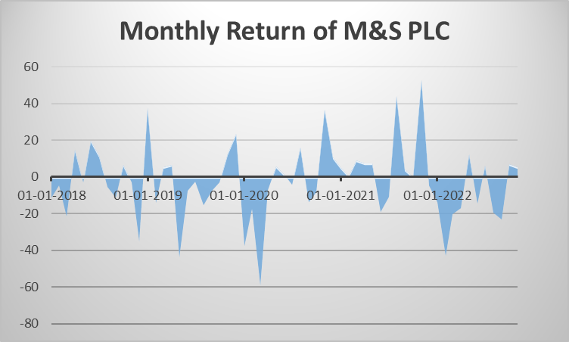

**Figure 1: Monthly return graph of M&S PLC**

(Source: Created by learner)

Average monthly return of Mark and Spencer PLC has presented growth of investment value in the last 5 years with sufficient volume because of a number of investors' participation in this organisation. This positive prospect of the return evaluates organisational profitability is growing in the last 5 years that attracts existing investors to invest more in this stock (Kaushik, 2020). Based on the return calculation of Mark and Spencer, present investors' wealth could grow by the next five years of investment. Analysing average return of Mark and Spencer termite possibilities of capital market to gain better growth of wealth.

Efficiency in the capital market and consideration as financial growth or gain of investment value, where investors analyse previous financial years growth of this organisation by collecting financial reports and stock price movement in previous years. According to Webster, (2022), analysing different activities in operational activity this organisation has presented a growth opportunity to creating better wealth in next few years. Investment in this organisation is possible by dividend policies because the last 5 years return of stock price is negative, however dividend pay-out of the stock is sufficient to create wealth for investors.

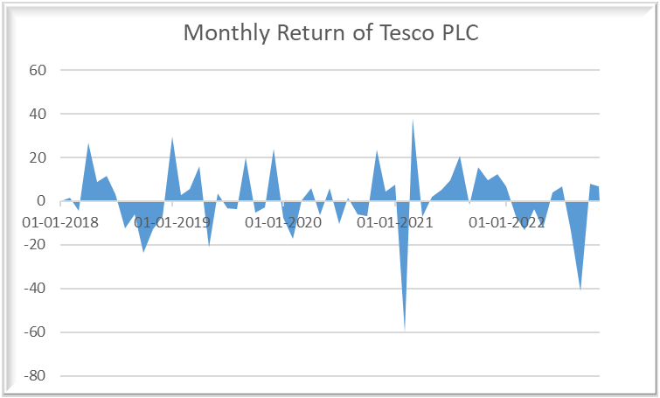

**Figure 2: Monthly return graph of Tesco PLC**

(Source: Created by learner)

Tesco PLC provides another prospect of the capital market about creating wealth by investment for a long period. According to calculated average return value and standard deviation gain knowledge investors approach towards these organisations is positive in the last 5 years. Capital market up and downs depending on movement of economic and industry growth potential in the next few years (Kaushik, 2020). Median value of Tesco PLC has been calculated ***1.560371*** that indicates this organisation stock price movement provides positive return to the shareholders (Kaushik, 2020).

The average return of the UK Retail Industry is 2.6%, which indicates continuous progress of this industry in the next 5 years. Comparative analysis between industry and Tesco PLC presents a better return that has been generated by this organisation. Positive growth of stock price evaluates investors potentiality making wealth by long term investment plan. On the other hand, Calculation of collective data of last 5 years performance has presented an average return of Marks and Spencer is - 2.58044 has indicated lack of stability in stock price.

# Conclusion

Analysing the capital market considering Marks and Spencer and Tesco PLC Analysis helps to conclude capital market efficiency and lack of efficiency. Analysing average return of Tesco PLC has presented investors' approach toward investment determined by previous years in financial performance. ***FTSE 100*** exploded and M&S PLC failed to maintain the same growth similar to index funds. Based on calculation, Tesco PLC average monthly return identified a positive return for investors. Analysing different activities in operational activity this organisation has presented a growth opportunity to creating better wealth in next few years.

Standard deviation of Tesco PLC determined please it in the stock price that helps to identify possible growth opportunities in next few years and also determined risk oriented with this stock price in future. ***Marks and Spencer PLC*** dividend yield is 0.18 that indicates investment in stock could be grown by the dividend gain oriented investment. Median value of Tesco PLC has been calculated that indicates this organisation stock price movement provides positive return to the shareholders. According to utilisation of return, average return calculation helps to gain knowledge about capital market up and down possibilities of this organisation based on its profitability. Rational activities of this organisation have determined Mark and Spencer PLC fail to achieve profitability that indicate stock price of this organisation has fallen to provide wealth to investors.

# Reference list

Bogle, D.A., Coyle, C. and Turner, J.D., 2022. Capital market development over the long run: the portfolios of UK life assurers over two centuries. European Review of Economic History, 26(3), pp.370-398.

Chircop, J., Gagnon, J. and Young, S., 2022. Capital market response to high quality annual reporting: evidence from UK annual report awards. Accounting and Business Research, pp.1-43.

DAS, I., 2022. INVESTOR PROTECTION IN INDIA AND UK–COMPARATIVE STUDY. Journal of Positive School Psychology, pp.4220-4231.

Dawd, I., Burton, B., Dunne, T. and Almujamed, H., 2018. Corporate reporting and disclosures in the emerging capital market of Kuwait: the perceptions of users and preparers. International journal of disclosure and governance, 15(2), pp.61-72.

Kaushik, M., 2020. Testing the degree of efficiency of Ireland Capital market with Efficient Market Hypothesis (EMH): A comparative analysis of Ireland Capital market efficiency with its neighbouring capital markets of the UK, Belgium and the Netherlands (Doctoral dissertation, Dublin, National College of Ireland).

Oliver, M.J. and Rutterford, J., 2020. ‘The capital market is dead’: the difficult birth of index‐linked gilts in the UK. The Economic History Review, 73(1), pp.258-280.

Seger, J., Stoner, K. and Pfnuer, A., 2021. The pricing of corporate real estate holdings on the UK capital market. Journal of Corporate Real Estate.

Webster, I., 2022. The rise and fall of capital market borrowing by UK local government over 200 years.

Finance.yahoo.com, *Historical data of stock price*, Accessed at; <https://finance.yahoo.com/quote/TSCO.L?p=TSCO.L&.tsrc=fin-srch> [Accessed at; 3-11-2022]

Finance.yahoo.com, *Historical data of stock price*, Accessed at; <https://finance.yahoo.com/quote/MKS.L?p=MKS.L&.tsrc=fin-srch> [Accessed at; 3-11-2022]

# Appendix

***Appendix 1***

***Tesco PLC***

|  |  |  |
| --- | --- | --- |
| Average monthly return |  | 0.521988 |
| Standard deviation | | 15.6602 |

|  |  |
| --- | --- |
| *Average monthly return* | |
|  |  |
| Mean | 0.521988 |
| Standard Error | 2.021723 |
| Median | 1.560371 |
| Mode | #N/A |
| Standard Deviation | 15.6602 |
| Sample Variance | 245.2419 |
| Kurtosis | 3.533563 |
| Skewness | -0.85767 |
| Range | 98.05319 |
| Minimum | -59.8973 |
| Maximum | 38.1559 |
| Sum | 31.31928 |
| Count | 60 |
| Confidence Level(95.0%) | 4.045459 |

***Mark & Spencer PLC***

|  |  |  |
| --- | --- | --- |
| Average |  | -2.58045 |
| Standard deviation | | 20.12244 |

|  |  |
| --- | --- |
| *Average monthly return* | |
|  |  |
| Mean | -2.58045 |
| Standard Error | 2.597796 |
| Median | -2.89555 |
| Mode | #N/A |
| Standard Deviation | 20.12244 |
| Sample Variance | 404.9126 |
| Kurtosis | 1.333458 |
| Skewness | 0.027776 |
| Range | 111.76 |
| Minimum | -59.16 |
| Maximum | 52.59999 |
| Sum | -154.827 |
| Count | 60 |
| Confidence Level(95.0%) | 5.198178 |